Valuelabs DevOps Interview Questions
on October 04, 2018

Here is the List of Valuelabs DevOps Interview Questions

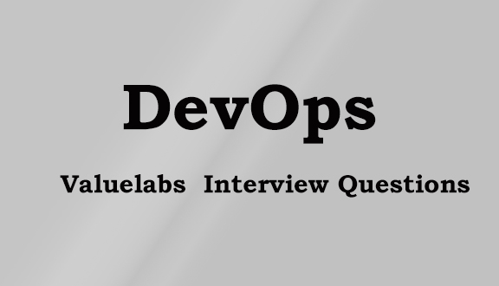

1.how to setup jenkins server and nodes using ec2 instances

2.About maven,ant,sonar
3.how to deploy application by using git and Jenkins

4.how to create docker image

5.how is docker different from vagrant

6.about ansible modules

7.about git fetch and git pull

8.how your present copmany help in your career ?

